BITS Pilani
Work Integrated Learning Programmes Division
Design and Operation of Data Centers
CC ZG508

OSPF Failover in a Leaf and Spine Network
Assignment 2 | Topic 1 | Lab Experiment
Student name: Moulik Patra
Repository: OSPF Failover Lab on GitHub

Abstract
I used a small leaf and spine network to test what OSPF does when an uplink goes down. Each leaf had two routes to the other host subnet, one through each spine. I disabled the uplink selected for the test flow, checked the forwarding table on both leaves, and kept ping running while the link was down.
The remaining path carried traffic in all three trials. The endpoints returned 126 replies from 126 probes at a nominal 200 ms interval. Both leaves eventually restored their second next hop. No missed probes were observed, but the probe interval leaves room for a shorter interruption.

Topology and addressing
Each host sits behind a leaf. Each leaf reaches both spines, so traffic between the host networks has two paths of the same length. This two-tier Clos example brings in Topic 5 as the topology used to study the Topic 1 failure [2].
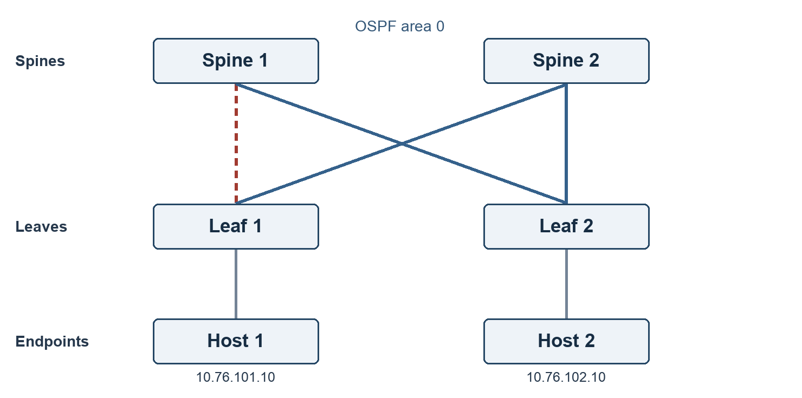
Figure 1 Lab topology. The dashed link from Leaf 1 to Spine 1 was disabled.
Segment | Subnet | Endpoints
Host 1 access | 10.76.101.0/24 | Leaf 1: .2 Host 1: .10
Host 2 access | 10.76.102.0/24 | Leaf 2: .2 Host 2: .10
Leaf 1 to Spine 1 | 10.76.0.0/29 | Leaf 1: .2 Spine 1: .3
Leaf 1 to Spine 2 | 10.76.0.8/29 | Leaf 1: .10 Spine 2: .11
Leaf 2 to Spine 1 | 10.76.0.16/29 | Leaf 2: .18 Spine 1: .19
Leaf 2 to Spine 2 | 10.76.0.24/29 | Leaf 2: .26 Spine 2: .27

The hosts use their local leaf as a default gateway. The routers have no default route. A separate bridge represents each link, with NAT disabled and no published ports [4]. The bridges and routers all run inside one Docker VM; the lab has no physical switches.

Routing configuration and method

OSPF settings
All router links belong to area 0. Transit interfaces have cost 10, and the host-facing interface has cost 1. The two paths from Leaf 1 to the remote host subnet therefore both cost 10 + 10 + 1 = 21. OSPF can retain both next hops when these costs match [1].
In the first bridge setup, multicast discovery did not form neighbours. I used explicit unicast neighbours in the working setup. The host-facing interfaces advertise their subnets without sending Hellos. This excerpt shows one Leaf 1 uplink [3].
interface to_s1
ip ospf area 0.0.0.0
ip ospf network point-to-multipoint non-broadcast
ip ospf cost 10
ip ospf hello-interval 1
ip ospf dead-interval 4
!
router ospf
ospf router-id 1.1.1.1
maximum-paths 2
neighbor 10.76.0.3 poll-interval 1
neighbor 10.76.0.11 poll-interval 1

Test sequence
- Wait until the Linux forwarding table on each leaf contains two OSPF next hops. Send ten no-fault probes from Host 1 to Host 2.
- For each trial, send 42 probes at 200 ms intervals. After the first six replies, disable Leaf 1 to_s1, the uplink selected by the kernel lookup for the test flow.
- Read both leaves until each shows only the surviving next hop. Keep the link down until ping finishes. Bring the link up and record when both next hops reappear on each leaf.
The runner times route observations from the start of each link command. The values include command and polling overhead. Reply gaps use the timestamps printed by ping.

Results
The no-fault baseline returned 10 of 10 replies. Each failure run removed one next hop on both leaves, and the remote subnet stayed reachable through Spine 2. The disabled link was restored after the probe stream ended.
Trial | Replies | Longest gap  (ms) | 1 next hop observed  L1 / L2 (ms) | 2 next hops restored  L1 / L2 (ms)
1 | 42/42 | 209.2 | 240.9 / 333.4 | 218.5 / 6035.0
2 | 42/42 | 215.2 | 207.6 / 315.7 | 196.3 / 5488.6
3 | 42/42 | 209.3 | 216.9 / 309.7 | 220.3 / 5752.3

L1 = Leaf 1; L2 = Leaf 2. The last two columns time changes in the forwarding table, measured from the start of the link-down or link-up command.

What changed
Before the fault, Leaf 1 had next hops through both spines for 10.76.102.0/24. With to_s1 down, only the next hop through Spine 2 remained. The return route on Leaf 2 also dropped to one next hop. After restoration, both leaves again showed two.

What the probes show
All 126 probes in the three trials got replies. The largest interval between replies was 215.2 ms. That is a sample of reachability during the test, not an exact bound on the time taken by OSPF to calculate a route. A short disruption between probes could go unobserved.
Leaf 2 regained its second next hop several seconds after Leaf 1 in these runs. The surviving path kept the hosts connected during the failure. The lab did not trace why the second next hop returned later on Leaf 2.

Forwarding table evidence
The entries below come from the recorded Linux route output. They show the two next hops before the fault, the surviving route during trial 1, and the return of both next hops after the link was brought up.
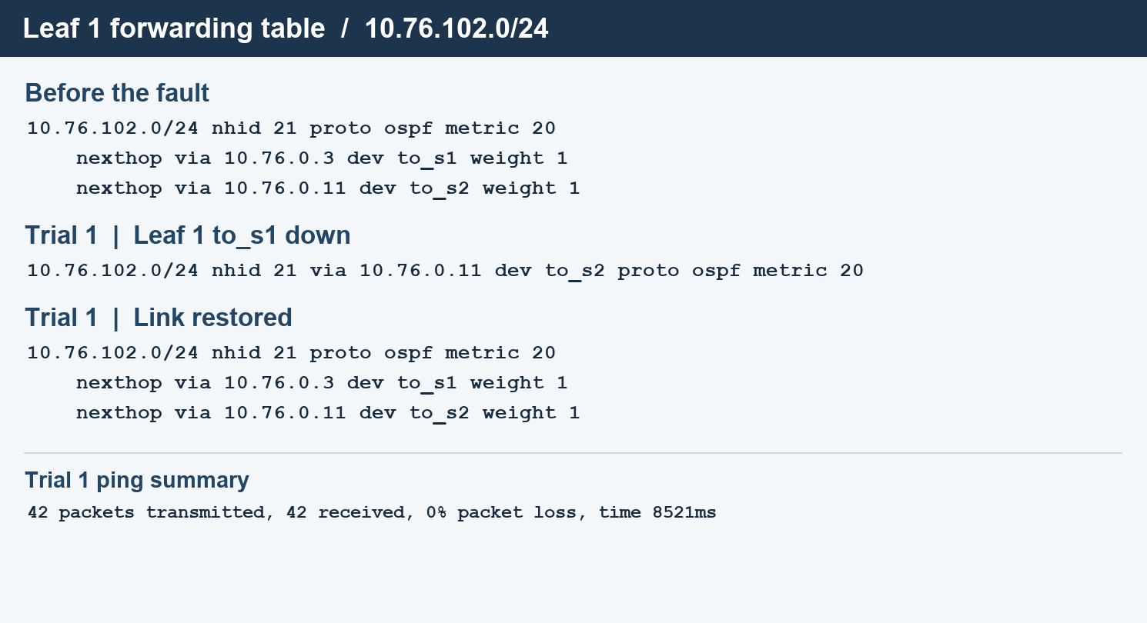
Figure 2 Excerpt from the recorded forwarding tables and ping output.
FRRouting shows an OSPF cost of 21 for the remote subnet. The Linux entry labels its own metric as 20. These are different fields; I used the FRRouting route to check the OSPF cost and the Linux table to check which next hops were installed.
The source archive includes the complete route snapshots and ping output, including the two leaves’ neighbour tables. The result file records the three trial timings and the software used.

Reproduction and conclusion

Run the experiment
From the source directory, start the lab, run the measurement and remove the containers when finished. A new run writes its own evidence under runs/.
docker compose up -d --build
python3 measure.py
docker compose down
The 10 November 2026 run used FRRouting 10.5.5_git, Docker Engine 29.9.2 (arm64), Compose 5.6.1, and Linux kernel 7.0.14-linuxkit. The FRRouting image requires NET_ADMIN and SYS_ADMIN in its router containers. This lab does not use host networking or privileged containers.

Conclusion
The second spine gave the network a usable route after the selected uplink went down. The important result was the change from two installed next hops to one while traffic continued at the probe interval. Recovery of full path redundancy was a separate event.
I would use a faster probe stream and collect routing event timestamps for a stricter outage target. These results apply to one flow, one type of link failure and one laptop. They do not establish traffic distribution under load, recovery from a leaf failure, or performance on physical switches.

References
[1] RFC 2328: OSPF Version 2, section 2.4
[2] RFC 7938: Use of BGP for Routing in Large-Scale Data Centers
[3] FRRouting 10.5: OSPFv2 configuration
[4] Docker Engine: Bridge network driver

